

Aditya Raj

BCIS309 – Work Integrated Learning Project, Software Development Pathway

Semester 1, 2021

SQL Test Automation for Ara Institute of Canterbury

Halfway Report – Version 0.3

Table of Contents

Document Control 3

Introduction 4

Project Details 5

Project Name 5

Overview of Industry Client 5

Project Overview – Current & Future Situation 5

Project Scope 6

Project Goals 6

Benefits of Project 7

Project Requirements 7

Expected Deliverables 8

Stakeholder Management 9

Project Hierarchy 9

Reporting and Meetings 9

Student Skills 10

Skills Required 10

Approach to Learning New Skills 10

Project Plan – High Level 11

Phases 11

Timetable 13

Burndown Charts 14

Resources/Access Required 14

Risk Management 15

Approach 15

Risk Table 15

Quality Assurance 16

Approach 16

Quality Assurance Table 16

Test Plan/Scenario/Cases 16

Methodology 17

Part A – Literature Review 17

Agile Scrum Methodology 17

Ethics 20

Relevance of ITP Code of Ethics 20

Good Faith 20

Integrity 20

Community Focus 20

Skills 20

Continuous Development 20

Informed Consent 20

Conflicts of Interest 20

Competence 20

Relevant Legislation 21

Privacy/Confidentiality 21

Copyright 21

Patents 21

Sustainability, Inclusive Practice and Te Tiriti o Waitangi 22

Relevance of Principles to Student and Industry 22

Reflections 23

Approach 23

Halfway Reflections 23

Bibliography 24

Appendices 25

Appendix A – Project Scope 25

Appendix B – Skills Examples 27

Appendix C – Planning Examples 29

Appendix D – Burndown Charts 32

Appendix E – Risk Management 34

Appendix F – Quality Assurance 35

# Document Control

|  |  |  |  |
| --- | --- | --- | --- |
| Date | Author | Version | Status of Document/Updates Made |
| 13/05/2021 | Aditya Raj | V0.1 | Document Creation |
| 19/05/2021 | Aditya Raj | V0.2 | First Draft Complete & Submitted for Marking |
| 21/05/2021 | Aditya Raj | V0.3 | Submitted Final Version |
|  |  |  |  |
|  |  |  |  |

# Introduction

This report serves to describe the process of the SQL Test Automation project up till the halfway mark including the growth I have made from the project proposal document. In this report, I will be describing the milestones that I have achieved along with this project as well as the many problems that I encountered and eventually resolved. The report will also investigate an overview of my future objectives which have been set according to my past outcomes including those that have been re-negotiated.

This document has been divided into sections, including the project details with the current and future situation of the project, the project scope with any changes from the proposal document, stakeholder management, the student skills used so far, the project plan with examples, burndown charts and risk management. Finally, the bibliography and appendices section is located at the end of the document.

# Project Details

This section serves to provide an overview of this project including information regarding the industry client and the project purpose and background.

## Project Name

SQL Test Automation

## Overview of Industry Client

The tutors of the Department of Enterprise and Digital Innovation at Ara Institute of Canterbury in Christchurch, New Zealand are the industry clients of this project.

## Project Overview – Current & Future Situation

The purpose of this project has been to deploy a product that allows students in database courses in computer labs at Ara Institute of Canterbury to submit their SQL Server language code work and get automated marks and feedback instantly. This is important to the industry clients, the tutors of these databases classes at Ara, because by using this product they will be able to save many weeks not having to manually download all their students work to execute and manually mark and provide feedback, also their students will not have to wait many weeks to get their marks and feedback returned, therefore time is saved, and manual work is automated.

According to the project proposal document, the completed product which will be deployed will be used by the students of database courses in computer labs at the institution, however, this may change depending on the outcome of the product, for example, a front-end user interface will need to be developed for students to use in order to get their marks and feedback returned, but if this is not possible with SQL Server and tSQLt, the tools and technologies involved, then an alternative product will be deployed which will only be used by the tutors of the classes in order to automatically mark each student work whist providing feedback, this information can then be shared with students. Even with this alternative outcome, the process still involves the purpose of saving time and manual work becoming automated.

# Project Scope

This section serves to outline the industry and academic goals that were set in my project proposal document and the progress made up till the halfway mark to achieving these goals. This section also covers the skills I required and the areas I have worked on up till the halfway mark.

## Project Goals

### Industry

With the progression of this project, I have learnt new skills and now better understand the tools and technologies needed for the development of this project’s product outcome. I have learnt and have been able to meet my industry goals, however in the way that was possible with the tools and technologies needed, for example, for the first goal, I expected to receive results such as YES or NO depending on the SQL Server code submitted as a student, however using Microsoft SQL Server and tSQLt, the database unit testing framework needed for the development for the product, I was able to get results such as SUCCESS or FAILURE or ERROR, although these were similar results to what I expected, the overall goal was changed according to these results.

At this stage of the project, I have not been able to provide a platform for students to use in order to self-mark their work according to the second goal in my project proposal which is to allow the student to self-mark without being revealed the correct answer, however, I have been able to write tSQLt unit tests that allow for results to be displayed only, without revealing the correct answer to the student (only if they do not investigate the RAW product code). In future increments of my product, my new industry goal is to add a front-end platform for students to use or if this does not work, an alternative goal is to provide a product for the tutor to use in order to automatically mark each student work whist providing feedback, this information can then be shared with students.

My third industry goal was to present feedback with the results of the tests, in which the student would receive feedback as to why their work is correct or not correct. At the halfway mark of this project, I have been able to develop the product outcome which shows some feedback including missing records of query tables, missing tables/objects, or simply WRONG ANSWER to the most unexpected results.

An example of these goals in action can be seen in a screenshot of the text output from Sprint 3 of the project, this screenshot is in the appendix A1 section of this document.

### Student

My goal as a student working on this project has been to develop an understanding of how to use tools and technologies that are needed for the development of the product outcome, I included tSQLt, the database unit testing framework for SQL Server in my project proposal, and this has been true, I have had a difficult time understanding this technology that is very new to me as well as the use of Microsoft SQL Server Management Studio 18. At the beginning of the project during Sprint 1, I spent many hours simply following tutorials and manual documentation of these tools and technologies to understand and familiarise myself with them so that I can efficiently work on developing my product outcome. I will be discussing the problems I faced and how I resolved them in the Development Phase of the Project Plan section in this document. As per my project proposal, my overall student goal is still, to successfully produce a deployable final product for this project.

## Benefits of Project

### Industry

The industry will benefit from this project by using a deployed product that saves a lot of time for both the tutors and the students where marking is automated and instant, benefit as per my project proposal, remains unchanged and I hope to deliver this benefit at the end of this project.

### Student

As a student working on this project, I hoped to benefit by having developed new skills using SQL Server and tSQLt framework within, this benefit as per my project proposal also remains unchanged as I have developed many new skills through this project so far and hope to gain more skills by the end of the project which will help me progress further in my IT career.

## Project Requirements

In my project proposal document, I had the following requirements, these are ways I progressed through them up till the halfway mark:

* Use of tSQLt framework and SQL Server 2017 and 2019 to test product across both versions in an event of a system-wide upgrade – testing was done using both versions on Ara computers (more about this in the Testing Phase of the Project Plan section).
* The product must work in room X205 at Ara Institute City Campus, other rooms may have the product deployed in the future – testing was done in X205 as well as other computer labs at Ara (more about this in the Testing Phase of the Project Plan section).
* The product must compare the student work with the model answer provided by the tutors, looking and comparing specifically at the fields, data, order, and tables in the SQL code files – the product so far does this successfully while providing a result and feedback (more about this in the Development Phase of the Project Plan section).

## Expected Deliverables

### Industry

As per my project proposal, my four deliverables for this project are on track to be completed, as I have done the following in development:

* The product marks student work from a directory (executed script with student code) and provides a correct or incorrect result.
* The product provides some words for feedback as to why the work is incorrect.

The following are future deliverables that are expected to be completed by the end of the project:

* The product allows students to self-mark, but without revealing to them the answers OR tutor uses the automated product to retrieve marks for the student work.
* The final deployable product without errors or bugs ready to use.

### Academic

These are the academic deliverables for this project that I have completed, taken from the project proposal but also with deliverables not mentioned before:

* Project Proposal & WIL Agreement
* Halfway Report
* Part A of Methodology Essay
* Academic Supervisor Halfway Assessment
* Industry Supervisor Halfway Assessment
* Weekly Meeting Reports
* Student Photo

The following academic deliverables are expected to be completed by the end of the project:

* Summary Profile Document
* Final Report
* Final Methodology Essay (Parts A, B & C)
* Panel Project Poster
* Panel Presentation
* Emerge Exhibit Poster

Appendix A2 outlines the timeline the deliverables for both industry and academic are due throughout this project. The final academic documents do not have an exact date yet, these are to be announced depending on the booked panel presentation and completion of industry work.

# Stakeholder Management

This section covers the information about the individuals involved in the project including the course convenor, industry supervisors and academic supervisors. I will also be covering how I have managed to communicate with them through this project.

## Project Hierarchy

The people directly and indirectly involved in this project are:



## Reporting and Meetings

According to the project proposal document, the main option of communication between meetings has been via emails and this has continued till now and will continue as this has been an effective way to communicate digitally. For reporting, I have had meetings with my industry supervisors, Amit and Alister, almost every week when appropriate as per the sprint cycles and meetings with my academic supervisor, Rob Oliver, has been every Friday at noon. More about these meetings will be discussed in the project planning section of this document. I have also attended class sessions with the course convenor, Dr David Weir, on Mondays and/or Thursdays from 3-5 pm.

# Student Skills

The skills needed for the project to effectively make use of the tools and equipment to complete the tasks that are scheduled for use and completion are covered in this section. My evidence of the use of these tools and equipment up to the halfway mark can also be found in this section.

## Skills Required

As per the project proposal document, the following skills were required, and these are the ways I made use of tools to complete tasks:

* Project Management/Organisation – I use an online tool called Trello to organise my tasks and manage my time, see Appendix B1 for evidence. I also use Microsoft Excel to complete the task planning for sprints (more about this in the Project Planning section of this document).
* Time Management – I used an online tool called Toggl Track to keep track of my time and manage it for both industry and academic work while making sure to meet weekly hour goals, see Appendix B2 for evidence.
* Teamwork – although I mentioned this in my project proposal, as a project of one, teamwork as a skill was not needed.
* Communication – I used Microsoft Outlook email to communicate with my industry and academic supervisors between meetings.
* Report Writing/Documentation – I used Microsoft Word for writing reports such as this and Microsoft Excel for my Sprint Backlog (more about this in the Project Planning section).
* Code Repository – I created a private GitHub repository and shared it with my industry supervisors for version control and code management, all my sprints can be found here. This is something that was not mentioned in the project proposal. See Appendix B3 for evidence.

All other skills that I already had mentioned in the project proposal in terms of ICT and from relevant L6 and L7 courses such as BCPR203 Database Management Systems, BCDE224 Best Programming Practices PHP (Database knowledge), BCDE213 Interactive Media Development (project management knowledge), etc, all have come in handy through the progression of this project.

## Approach to Learning New Skills

As per my project proposal, I had mentioned that I would use time outside the hours of working on the project to learn new skills, however, I had to spend a lot of time while working on the project to learn the skills required such as the tSQLt framework and SQL Server language for me to start and progress with the sprints.

# Project Plan – High Level

This section serves to focus on the planning that was done in the project proposal as well as what was done up till the halfway mark of this project. This section involves the steps taken at each phase of the project including resources consumed and the time taken to complete the project.

## Phases

Following the project proposal, the project involves the use of the Agile Scrum methodology, each sprint consists of six phases for software development, the following graph shows the phases throughout each sprint (MacKay, 2019):

For this project, I have been completing these phases for each sprint. At the beginning of each sprint, I met with my industry supervisors to discuss goals, requirements, and the outcomes of what they need at the end of the sprint, as per this I was able to plan for what I needed to work on, I included the discussed requirements in a “Industry Backlog” excel spreadsheet.

The design and development phases were established by coding the product which involved Microsoft SQL Server 2017 and 2019, and tSQLt database unit testing framework within SQL Server, which allows for the implementation of unit tests in T-SQL, a proprietary extension to the SQL Server language.

I did manual testing while coding the product throughout the development phase, it was also tested by my industry supervisors during our sprint meetings which also involved the evaluation of the product for the next steps. The following sections explain these phases in greater detail with evidence of my work with steps taken according to (MacKay, 2019).

### Planning

Each sprint focuses on a product that is built within a sprint period, frequent planning and setting of goals allow the team to focus on objectives and increase productivity (Business News Daily Editor, 2020). For this project, I completed an excel spreadsheet called “Industry Backlog” that I used to plan my sprints, including the breakdown of all the tasks that I plan to complete by the end of each sprint, the status of each sprint changed from “not started” to “in progress” and “done” when completed. These steps were taken according to (MacKay, 2019). Appendix C1 shows evidence of task planning for Sprint one taken from the Industry Backlog spreadsheet. Anything that was not started was passed onto Sprint two.

Within the industry backlog spreadsheet, I also have other tabs which account for the sprint backlog and the product backlog as well. The Sprint backlog involves the planning of the overall sprint and what requirements need to be established by the end of the sprint cycle whereas the Product backlog involves the planning of the product outcome which incorporates the user story of the sprint cycle. Appendix C2 shows evidence of the Product Backlog from the Industry Backlog spreadsheet.

### Design and Development

As per the planning phase of the software development process, the design and development of the product can begin, the design phase can involve creating prototypes or wireframes using the requirements obtained and planned for what the product will look like and how it will function which will help code the product in the development phase (MacKay, 2019).

For the design of my products, I created simple low-fidelity wireframes using the user story from the product backlog and using the sprint requirements from the Sprint backlog. These wireframes helped guide me to how I needed to build the product within the Sprint cycle. Appendix C3 shows evidence of a wireframe I did for the first Sprint.

With all the planning and designing completed, the development of the product according to the requirements of the sprint cycle can begin. This phase is known to be the most difficult and may consume a lot more time than what you allocate or may also become risky causing scope creep if not done cleanly and efficiently, according to (MacKay, 2019), this was true for me too because since tSQLt was a brand new unit testing framework for me, I needed to use a lot of time to play around with the new T-SQL language and the features of the framework, however, the products produced with sprints till date have been done well, according to my industry supervisors. As evidence of the development phase, Appendix C4 shows code from the second sprint, produced using Microsoft SQL Server Management Studio, SQL Server 2017, and unit testing framework tSQLt.

### Testing and Evaluation/Meeting

At the end of each sprint, the team meets to test and get feedback according to the Scrum framework and the software development process (MacKay, 2019), I met my industry supervisors at the end of each sprint to show and tell what I had done, and they tested it, this involved running the product code on various computers as per the user type and version of the software involved, for example, a test involved running product code on an Ara tutors user account (industry supervisor) using SQL Server 2017, and Ara students user account (that’s me) using SQL Server 2017 and then SQL Server 2019. Appendix C5 shows evidence of different testing that occurred during the sprint meetings, these were signed off.

As per the testing, I was provided feedback for the evaluation of what I had done well and what I should do for the next sprint, from this I will be able to start the next sprints process. The following table shows evidence of sprint meetings for this project so far:

|  |  |  |  |
| --- | --- | --- | --- |
| **Attendees** | **Sprint** | **Date** | **Time** |
| Amit, Alister, Rob, Aditya | - | 7/04/2021 | 12:30:00 |
| Amit, Rob, Aditya | - | 9/04/2021 | 12:00:00 |
| Amit, Alister, Aditya | 1 | 15/04/2021 | 14:00:00 |
| Amit, Rob, Aditya | 2 | 28/04/2021 | 13:00:00 |
| Amit, Aditya | 3 | 12/05/2021 | 13:00:00 |

## Timetable

I have been provided with a requirement of at least 300 industry hours and 150 academic hours (total of 450 hours for the project) to complete the project in total, in my project proposal I have estimated 30 hours of industry hours weekly and 9 academic hours weekly for the project only, I have attempted to meet these goals every week till date – more on this in the Burndown Charts section. I also must balance my other course work for BCDE321 Advanced Programming, a part-time job, and other commitments. This is an estimate of my weekly timetable now:

|  |  |  |  |  |  |
| --- | --- | --- | --- | --- | --- |
| Monday | Tuesday | Wednesday | Thursday | Friday | Saturday |
| Between  6 am – 2 pm  Industry/  Academic Work | **Between**  **6 am – 5 pm**  Industry/  Academic Work | **10 am – 12 pm**  Advanced Programming Class | **Between**  **6 am – 4 pm**  Advanced Programming Work | **Between 6 am – 11 am**  Industry/  Academic Work | **Between 6 am – 6 pm**  Industry/  Academic Work |
| 3 pm – 5 pm  WIL Session | **6 pm – 10 pm**  Community Commitment | **Between**  **1 pm – 2 pm**  Industry Meeting | **5 pm – 9 pm**  Part-Time Job | **12 pm – 1 pm**  Academic Meeting | **6 pm – 12 am**  Family Commitments |
| Between  6 pm – 12 am  Industry/  Academic Work | **Between**  **10 pm – 12 am**  Industry/  Academic Work | **Between**  **3 pm – 12 am**  Industry  /Academic Work | **Between**  **10 pm – 12 am**  Advanced Programming Work | **1 pm – 3 pm**  Advanced Programming Class |  |
|  |  |  |  | **4 pm – 11 pm**  Part-Time Job |  |

Depending on the week, I prioritize certain industry and academic work and do them when appropriate or possible in the week.

## Burndown Charts

### Industry

Please see appendix D1 for the latest burndown of the industry hours that I have completed to date. My weekly goal for industry hours has been 30 hours, the lowest I achieved was 17 hours in the first week of the term break and the highest I achieved was 34.5 hours in week 10. I hope to continue with 30 hours as my weekly goal until the end of the project.

### Academic

Please see appendix D2 for the latest burndown of the academic hours that I have completed to date. My weekly goal for academic hours has been 9 hours, the lowest I achieved was 3 hours in the first week of the term break and the highest I achieved was 45 hours in week 6 (this week I had not started my industry work and was completing my project proposal).

## Resources/Access Required

As per my project proposal, I had mentioned the need for access to rooms N209 and X205 at Ara Institute, City Campus because it is a requirement that the final product is deployed in X205 and to test this, this room needs to be used. N209 was to be used to work on the code. I also required access to a computer running SQL Server 2017 and 2019 for the testing of the product on both versions because it is a requirement that the deployed product be executable on both versions, whichever is installed on a specific computer.

From the project proposal, I have worked on my industry code at Ara in various computer rooms for testing and at home on my laptop, I have also tested the product with my industry supervisor on an Ara account with Staff privileges and an Ara account with Student privileges.

# Risk Management

Risks may be present or may arise during the runtime of the project, this section covers these risks including their solutions or methods of mitigation for these issues and risks. The initial risk management was done in the project proposal and the halfway stage will be covered in this section.

## Approach

The risk table features a list of risks that could arise during the runtime of the project. The table explains the condition of the risks, their consequence, their probability, impact and exposure measurements, their mitigation strategy, their contingency, and triggers. There is a range of variables present in each of the risks documented, they have been identified in the risk table. These risks will be reassessed in this halfway report and the final report for this project.

## Risk Table

The halfway stage risk management table can be found in Appendix E1 of this document. It features 5 risks covering various types of risks that may arise during the project ordered from the highest to lowest exposure rating as assessed from the initial stage.

The risk management table has been derived from the Microsoft Risk Template Tool. The risk probability is the likelihood of a risk condition occurring, it must be between 1% and 99%, that is 1% to 30% for low risk, 31% to 70% for medium risk and 71% to 99% for high risk. The impact value is the effect of the risk consequence which must be between 1 and 10. I have selected my values dependent on the history, previous occurrences, and my experience of these risks, with my estimation of these risks, occurring. The exposure value is calculated by multiplying risk probability with risk impact, the table is sorted from highest exposure to lowest exposure to prioritize risks.

From the project proposal document, the main changes were to the decrease in exposure to the condition of COVID-19 Alert level change, this has gone from 1.05 down to 0.25. While the chance of meeting sick has increased from exposure 1 to 1.8, this is because of the winter weather arriving now. The highest risk that remains at #1 is not meeting submission deadlines due to the increased workload at the halfway mark of this project.

# Quality Assurance

Steps must be taken to ensure that the project meets prerequisites that have been requested and that these are at an expected standard. This section covers the processes that have been set up within the industry to fulfil these quality assurance requirements.

## Approach

For the quality assurance of my code and outcomes produced, my approach has been to adhere to official online manuals and tutorials of tools and technologies that I use, for example, tSQLt which is a test-driven database development tool and the SQL Server language, I have made sure to write code that is of best programming practices by adhering to the Microsoft online documentation and tSQLt official full manual.

## Quality Assurance Table

The quality assurance table can be found in Appendix F1 section of this document. It covers a list of all deliverables, the criteria for acceptance and who all accept them.

## Test Plan/Scenario/Cases

At the end of every sprint, my industry supervisor checks and tests my work, this is a way the quality of the code is reviewed, by a qualified person. The product produced is tested using unit tests and manual testing in which the supervisor does functional and usability testing to evaluate changes for the next sprint.

# Methodology

## Part A – Literature Review

This section serves to discuss the literature review of the Agile Scrum methodology – extracted from the Methodology Essay.

## Agile Scrum Methodology

The SQL Test Automation project at Ara Institute of Canterbury involves the use of the Agile Scrum methodology, an incremental development framework that allows for teams to collaborate while working on complex projects. This project applies the Agile Scrum methodology because of its many advantages that help satisfy the requirements of the company project unlike other methodologies such the Waterfall which because of its linear process does not allow for constant improvement and innovation for products in the ever-changing software market (Muslihat, 2018).

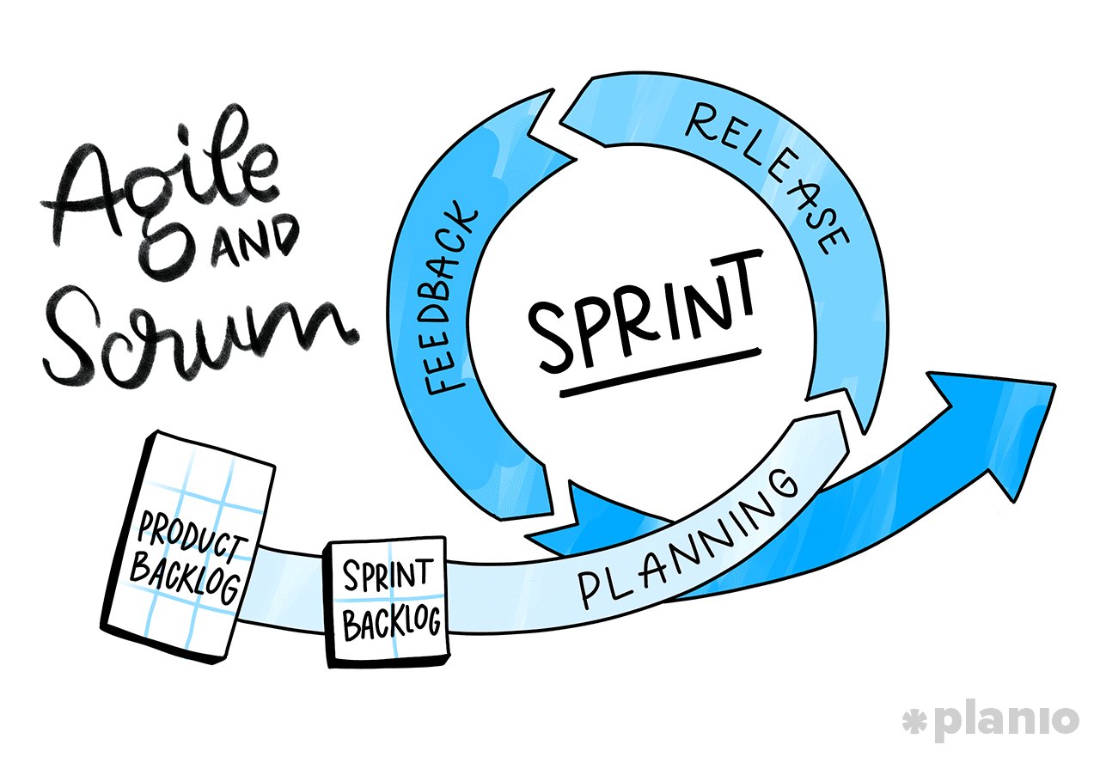

Figure 1 Agile and Scrum Diagram (MacKay, 2019)

With the Agile Scrum methodology, I was able to work in increments, by adding required features and making changes to the product in each sprint as per feedback from my industry supervisors. This methodology has been easy to understand and has allowed me to prioritise important features over features that will never be used. I have put into practice these steps of the process according to (Business News Daily Editor, 2020).

The following graph shows the process of the framework:

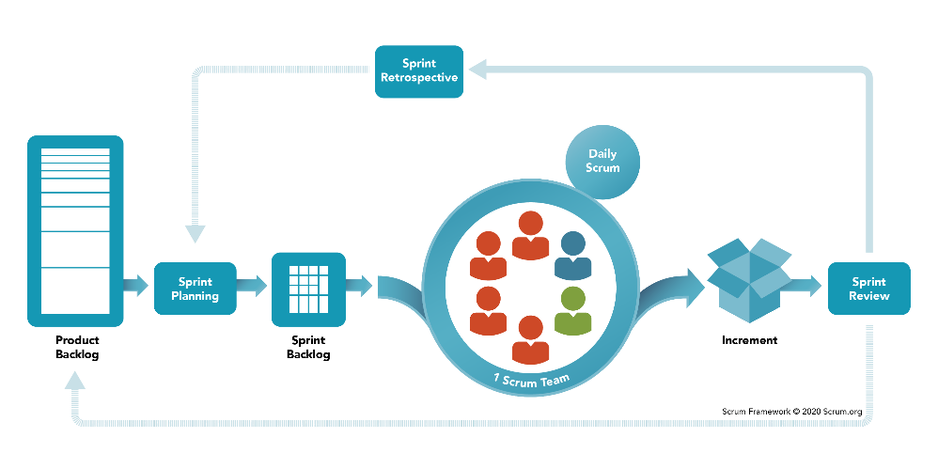

Figure 2 Scrum Framework (Scrum.org, 2020)

### Scrum

Scrum is a framework that allows for useful collaborations between teams that working on products with complexity. A scrum is made up of meetings, roles and tools that help teams to work together with a better arrangement and workload management (Business News Daily Editor, 2020). Scrum provides many benefits to complicated projects by requiring teams to complete a backlog, benefits to companies that value the results and benefit companies that accommodate their customers by developing products that meet customer needs and requirements (Business News Daily Editor, 2020).

### Agile

The Agile process allows the team to better manage their project by organising it into many stages, allowing for continuous teamwork with the stakeholders while steadily improving the product at every stage (Business News Daily Editor, 2020).

The 12 principles of agile that make projects superior are:

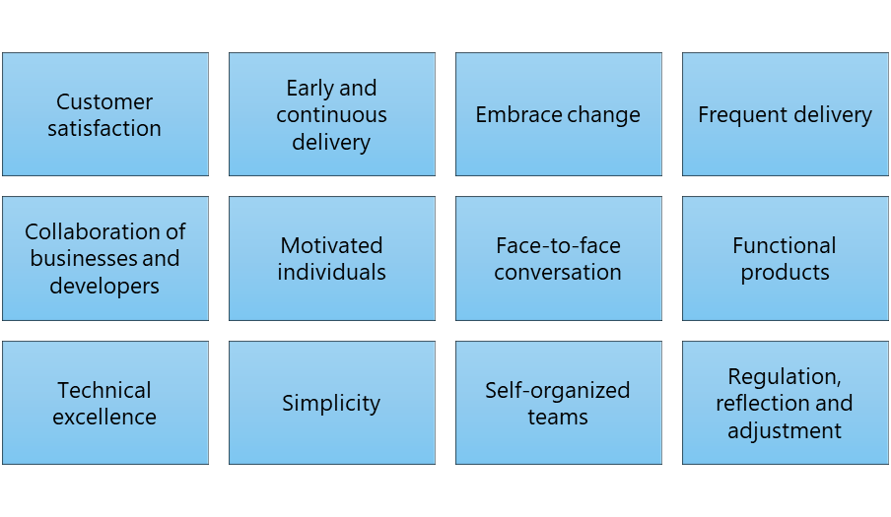

Figure 3 Principles of Agile (Business News Daily Editor, 2020)

### Sprints

Iterations are made up of two to four-week sprints in which each sprint has a goal for a deliverable product (Business News Daily Editor, 2020), however as a team consisting of one person, I have been doing sprints of one to two weeks. The purpose of Agile is to move fast while releasing frequently and responding to the needs of the industry client, therefore a complete list of requirements before starting work is not needed, instead, work continues in a single direction with the understanding that the progression will change through the project (MacKay, 2019).

### Pros and Cons

The following are the pros and cons of the Agile Scrum Methodology (Henricksen, 2019):

|  |  |
| --- | --- |
| Pros | Cons |
| Easy to explain and understand and light framework. | The product results are expected at the end of each sprint, teams need to work faster/harder. |
| Feedback allows changes to happen and better adapt the product to the company. | Scrum implementations can fail due to many company reasons. |
| Important features are prioritised over features that will never be used. | Excessive embracing change can lead to scope creep. |
| With scrum, the sprints are visible to all team members for them to work on. | Developers may not want to spend time on meetings. |

# Ethics

There may be ethical issues involving the project and its completion, this section outlines these ethical issues that may arise and how they will be dealt with.

## Relevance of ITP Code of Ethics

These ethics have been outlined as per reference: (IT Professionals New Zealand).

## Good Faith

With good faith, people must be treated with dignity, equality, be without discrimination, be considered of, and the values and cultural sensitivities of all groups in the community affected by the work being conducted in the project.

## Integrity

With integrity, people must behave with honour, dignity, and integrity to be worthy of the trust of the profession and encourage it within the community. To apply appropriate judgement, apply honesty and exercise initiative to participate positively to the well-being of the public in general and the project.

## Community Focus

Before your responsibility to the profession and interests whether sectional or private, the prosperity of the community must come before the project.

## Skills

Without the settlement of other tenets, skills and knowledge are to be applied in the interest of the client/employers for/on behalf of whose actions are done for the project.

## Continuous Development

While promoting the collective wisdom of the profession, members of the team will continue to develop knowledge, skills and expertise during their careers while doing their best to actively promote their peers to do the same, for the project.

## Informed Consent

To remain informed, there should be steps taken. Clients, employers of the economic, social, environmental, or legal consequences may arise from actions carried out during the project.

## Conflicts of Interest

Clients shall be informed if there are any conflicts of interest, of which there is the observation of, between the work shown and the awareness of the client or employee, which can undesirably affect the work done in the project.

## Competence

Professional practice should be obeyed, as well as services delivered and advice thoroughly and carefully, within the areas of competency for the project.

# Relevant Legislation

## Privacy/Confidentiality

Regarding the project, the product that is developed will need to collect Ara Institute student information such as full name, student ID number, etc, as well as the course code and assessment number of the work they are submitting for automated marking. As per these requirements, The Privacy Act 2020 will be considered to make sure that the student information and work stay private and only for the use of marking their work via the SQL Test Automation product.

## Copyright

Efforts will be made to create original work for the project, if for any reason, other people’s work is needed, they will be appropriately asked for permission and acknowledged, and this will be done according to the copyright licence they have given their work. The product developed part of this project will only be made available within Ara Institute for private use by students and tutors only, it will not be used publicly or outside Ara Institute.

## Patents

The product because of this project may or may not be patented by the industry supervisors at Ara Institute as it is for use only within Ara Institute. If patented, this will stop others from making, using, or selling the product for up to 20 years and the rights will exist within the Canterbury region.

# Sustainability, Inclusive Practice and Te Tiriti o Waitangi

The four principles that must be obeyed during the runtime of the project are covered in this section. Their meanings will be covered.

## Relevance of Principles to Student and Industry

### Kaitiakitanga

For work to be carried out and completed, there should not be any personal issues and waste to the company resources that have been provided by the industry sponsor for the project. The reputation of the industry sponsor is reflected by this. The attitudes in the workplace and the personal reputation as a worker.

### Rangatiratanga

Any decisions or choices made concerning the project must be correctly assessed and adhered to the resources made ready, also including taking opinions of other team members and the industry supervisor.

### Whanaungatanga

The industry supervisor must be consulted to ensure that tasks are being carried out in order and within the set expectations. All reporting done in the team means that all team members part of the project understands what is happening so that they can assist when needed, doing this ensures that relations grow within the team.

### Mana Reo

Efforts should be made to ensure that the use of Te Reo or other languages is being accommodated by the team members on the project.

# Reflections

The following section grows from the project proposal and now features reflections from the beginning of this project till the halfway mark.

## Approach

For the reflection of lessons learning during the runtime of this project, notes have taken by writing down what needs to be worked on for next time, this includes what changes need to be made before work beginning to avoid future mistakes or liabilities. Time needs to be taken out to reflect on what is happening and what can be done so that work can happen easier or more efficiently. Work should be done by saving time and resources, these reflections will help with that in mind.

## Halfway Reflections

From the beginning of the project till now, I have had 3 main problems or issues that I needed to reflect on to learn from them, these are the reflections:

* The unit testing framework, tSQLt, and the T-SQL language have been a steep learning curve for me, although I did have knowledge of MySQL which is similar to SQL Server, the language that I use in this project, I have had to take extra time to work on full learning and understand the tool and technologies to start doing actual work from Sprint 1, however now I understand much of these tools and technologies for me to be able to finish this project successfully, I have learnt from my mistakes along the way.
* From the project proposal, I did not have a clear understanding of what I needed to produce for the outcomes this project, it took me time to not only learn the tools and technologies involved, but It also took me time to figure out got to get the expected outcomes of this project, however at the halfway mark, I understand what I need to do, I have learnt from my mistakes along the way.
* Some technical issues I faced so far is the use of schema and databases, I started off using schema to collect tables, objects and data into it, however, I learnt that schema is unorganised, and tables tend to fall out of the collection, making it hard to make objects work together, from this experience, I tried using databases and this worked, all my tables and objects became organised, and my code worked perfectly.

# Bibliography

Business News Daily Editor. (2020, February 25). *What Is Agile Scrum Methodology?* Retrieved April 3, 2021, from Business News Daily: https://www.businessnewsdaily.com/4987-what-is-agile-scrum-methodology.html

Henricksen, T. (2019, January 23). *Scrum pros and cons.* Retrieved April 4, 2021, from Medium: https://medium.com/@TomHenricksen/scrum-pros-and-cons-acf6b53b1ad6

IT Professionals New Zealand. (n.d.). *The ITP Code of Ethics.* Retrieved March 30, 2021, from IT Professionals New Zealand: https://itp.nz/Members/Code-of-Ethics

MacKay, J. (2019, October 2). *Software Development Process: How to Pick The Process That’s Right For You.* Retrieved May 3, 2021, from Plan.io: https://plan.io/blog/software-development-process/

Muslihat, D. (2018, March 2). *Agile Methodology: An Overview.* Retrieved April 3, 2021, from Zenkit: https://zenkit.com/en/blog/agile-methodology-an-overview/

Scrum.org. (2020, November). *What is Scrum?* Retrieved May 4, 2021, from Scrum.org: https://www.scrum.org/resources/what-is-scrum

# Appendices

The following appendices have been presented from the above sections of this document.

## Appendix A – Project Scope

### Appendix A1 – Project Goals Example

The following screenshot shows the text output of the testing script from Sprint 3 when executed, the industry project goals can be seen in action:

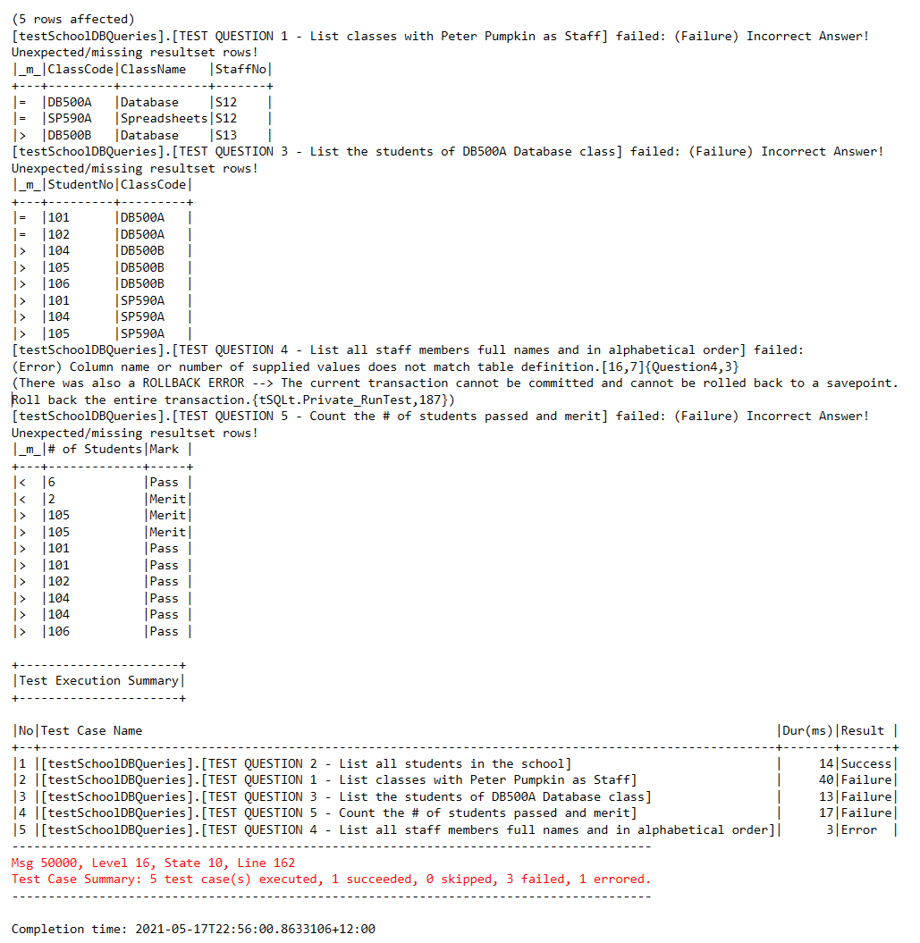

### Appendix A2 – Project Deliverables Timeline

This table shows all the deliverables including academic and industry work. The final academic documents do not have an exact date yet, these are to be announced depending on the booked panel presentation and completion of industry work.

|  |  |  |  |  |  |  |  |
| --- | --- | --- | --- | --- | --- | --- | --- |
|  | | **Monday** | **Tuesday** | **Wednesday** | **Thursday** | **Friday** | **Teaching Week** |
| March | 1 |  |  |  |  |  | **2** |
| 8 |  |  |  |  |  | **3** |
| 15 |  |  |  |  |  | **4** |
| 22 | Otago Anniversary |  |  |  | Autumn Graduation | **5** |
| 29 |  |  | Weekly Academic Meeting |  | *Easter* | **6** |
| April | 5 | *Easter* | *Easter* | **Project Proposal & WIL Agreement Due** Weekly Academic Meeting |  |  | **7** |
| 12 |  |  |  | Sprint 1 Due Show and Tell | Academic Meeting | **8** |
| 19 | **Term Break** |  |  |  | Academic Meeting | **BK** |
| 26 | *Anzac Day* |  | Sprint 2 Due Show and Tell |  | Academic Meeting | **BK** |
| May | 3 |  |  |  |  | Academic Meeting | **9** |
| 10 |  |  | Sprint 3 Due Show and Tell |  | Academic Meeting | **10** |
| 17 |  |  |  |  | **Halfway Assessments Due** Academic Meeting | **11** |
| 24 |  |  | Sprint 4 Due Show and Tell |  | Academic Meeting | **12** |
| 31 |  |  |  |  | Academic Meeting | **13** |
| June | 7 | *Queen's Birthday* |  | Sprint 5 Due Show and Tell |  | Academic Meeting | **14** |
| 14 | Study Week |  |  | Final Product Due Show and Tell | Academic Meeting | **15** |
| 21 | Exam Week |  | *Advanced Programming Exam* |  | Academic Meeting | **16** |
| 28 | Exam Week |  |  |  | **ALL ACADEMIC WORK DUE?** | **17** |

## Appendix B – Skills Examples

### Appendix B1 – Trello (Organisation Tool)

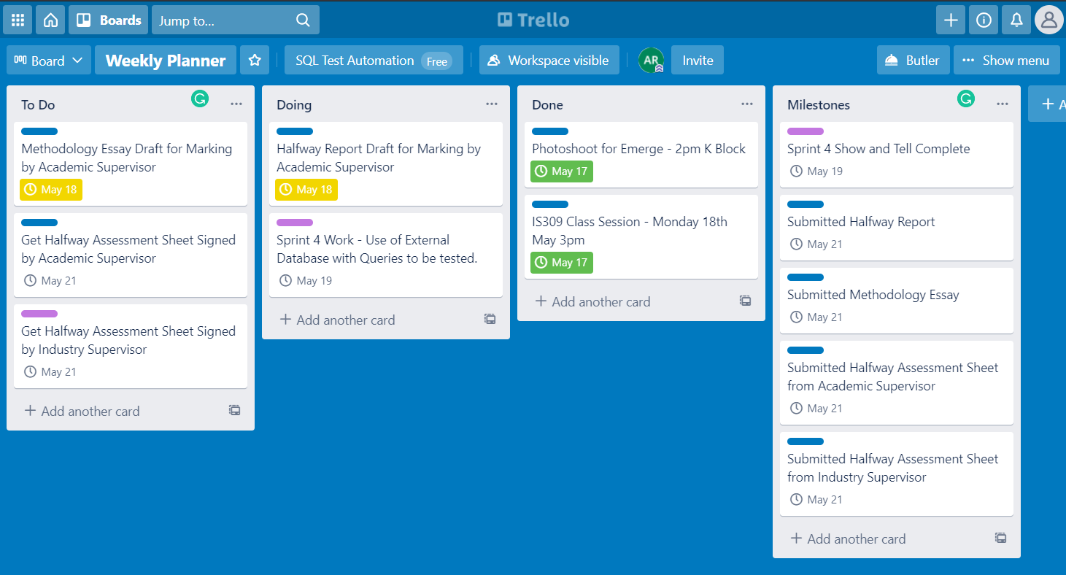

### Appendix B2 – Toggl Track (Time Management Tool)

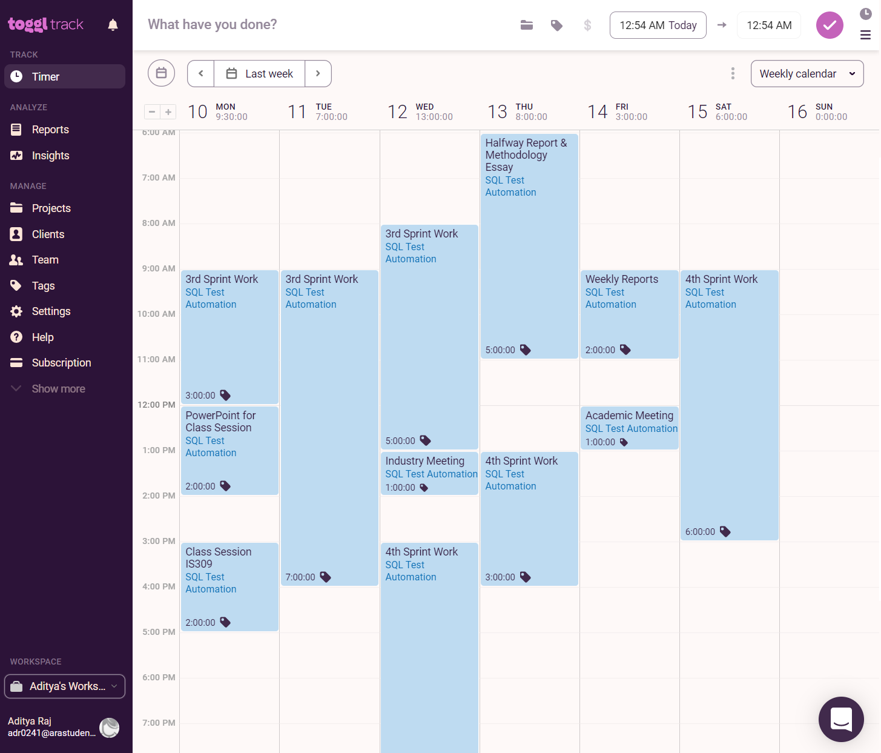

### Appendix B3 – GitHub Repository Example

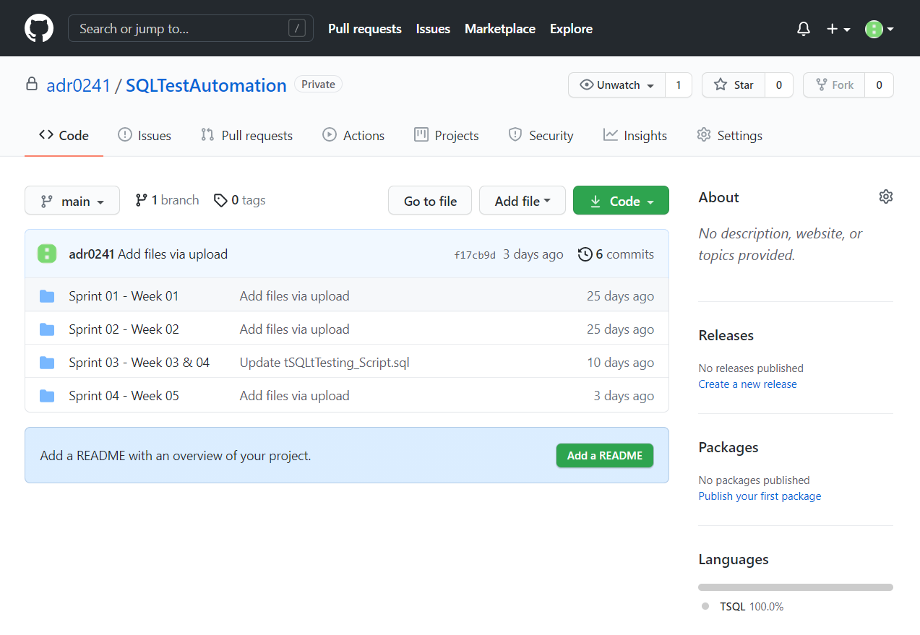

## Appendix C – Planning Examples

### Appendix C1 – Task Planning for Sprints

|  |  |  |  |  |
| --- | --- | --- | --- | --- |
| **Task Planning - Sprint #1** | | | | |
| **Task** | **Actual Effort** | **Task Status** | **Done** | **Completion Date** |
| Look at how tSQLt Compare Table works | 30 | Done | Done | 15/04/2021 |
| Get/Make a sample database | 30 | Done | Done | 15/04/2021 |
| Do a join query - All orders with Customer Name | 30 | Done | Done | 15/04/2021 |
| Use join query as the correct answer |  | Not Started |  |  |
| Make a test with different order fields, sorted differently | 40 | Done | Done | 18/04/2021 |
| Make a test with fields missing | 40 | Done | Done | 18/04/2021 |
| Make a test with spelling mistakes | 40 | Done | Done | 18/04/2021 |
| Make a test with case sensibility issues |  | Not Started |  |  |
| Make all code work with SQL Server 2019 |  | Not Started |  |  |
| **TOTAL** | **210** |  |  |  |

### Appendix C2 – Product Backlog

|  |  |  |  |  |  |
| --- | --- | --- | --- | --- | --- |
| **Product Backlog** | | | | | |
| **Priority** | **Story** | **Sprint** | **Sprint Code Name** | **Estimated Effort** | **Story Status** |
| 1 | As an Ara student, I want to identify mistakes in my work, so that it can help me find out what I did wrong. | 1 | Compare queries, identify mistakes – notify the student whether their SQL server code is correct with a SUCCESS or not correct with a FAILURE/ERROR result. | 400 | Done |
| 2 | As an Ara student, I want to compare some of my work with the model answer, so that it can help me find out what I did wrong. | 2 | Identify Table, Test Datatypes with Insert, Test Inner-Join Query - Use of CorrectAnswer & WrongAnswer Schema | 400 | Done |
| 3 | As an Ara student, I want to compare some of my work with the model answer, so that it can help me find out what I did wrong with feedback. | 3 | Multiple Questions in a Test need Multiple Queries - Use of lots of queries and tests for them. | 500 | Done |
| 4 | As an Ara student, I want to compare all my work with the model answer, so that it can help me find out what I did wrong with feedback. | 4 | Use existing database with the testing script - Make testing script using actual Ara tests | 400 | In Progress |

### Appendix C3 – Wireframe Design for Sprint One

### Appendix C4 – Code Development from Sprint Two

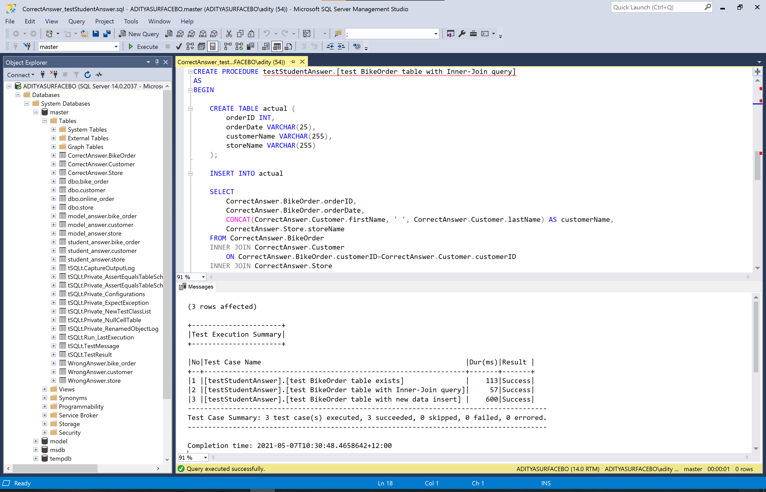

### Appendix C5 – Testing Sign-Off Sheet

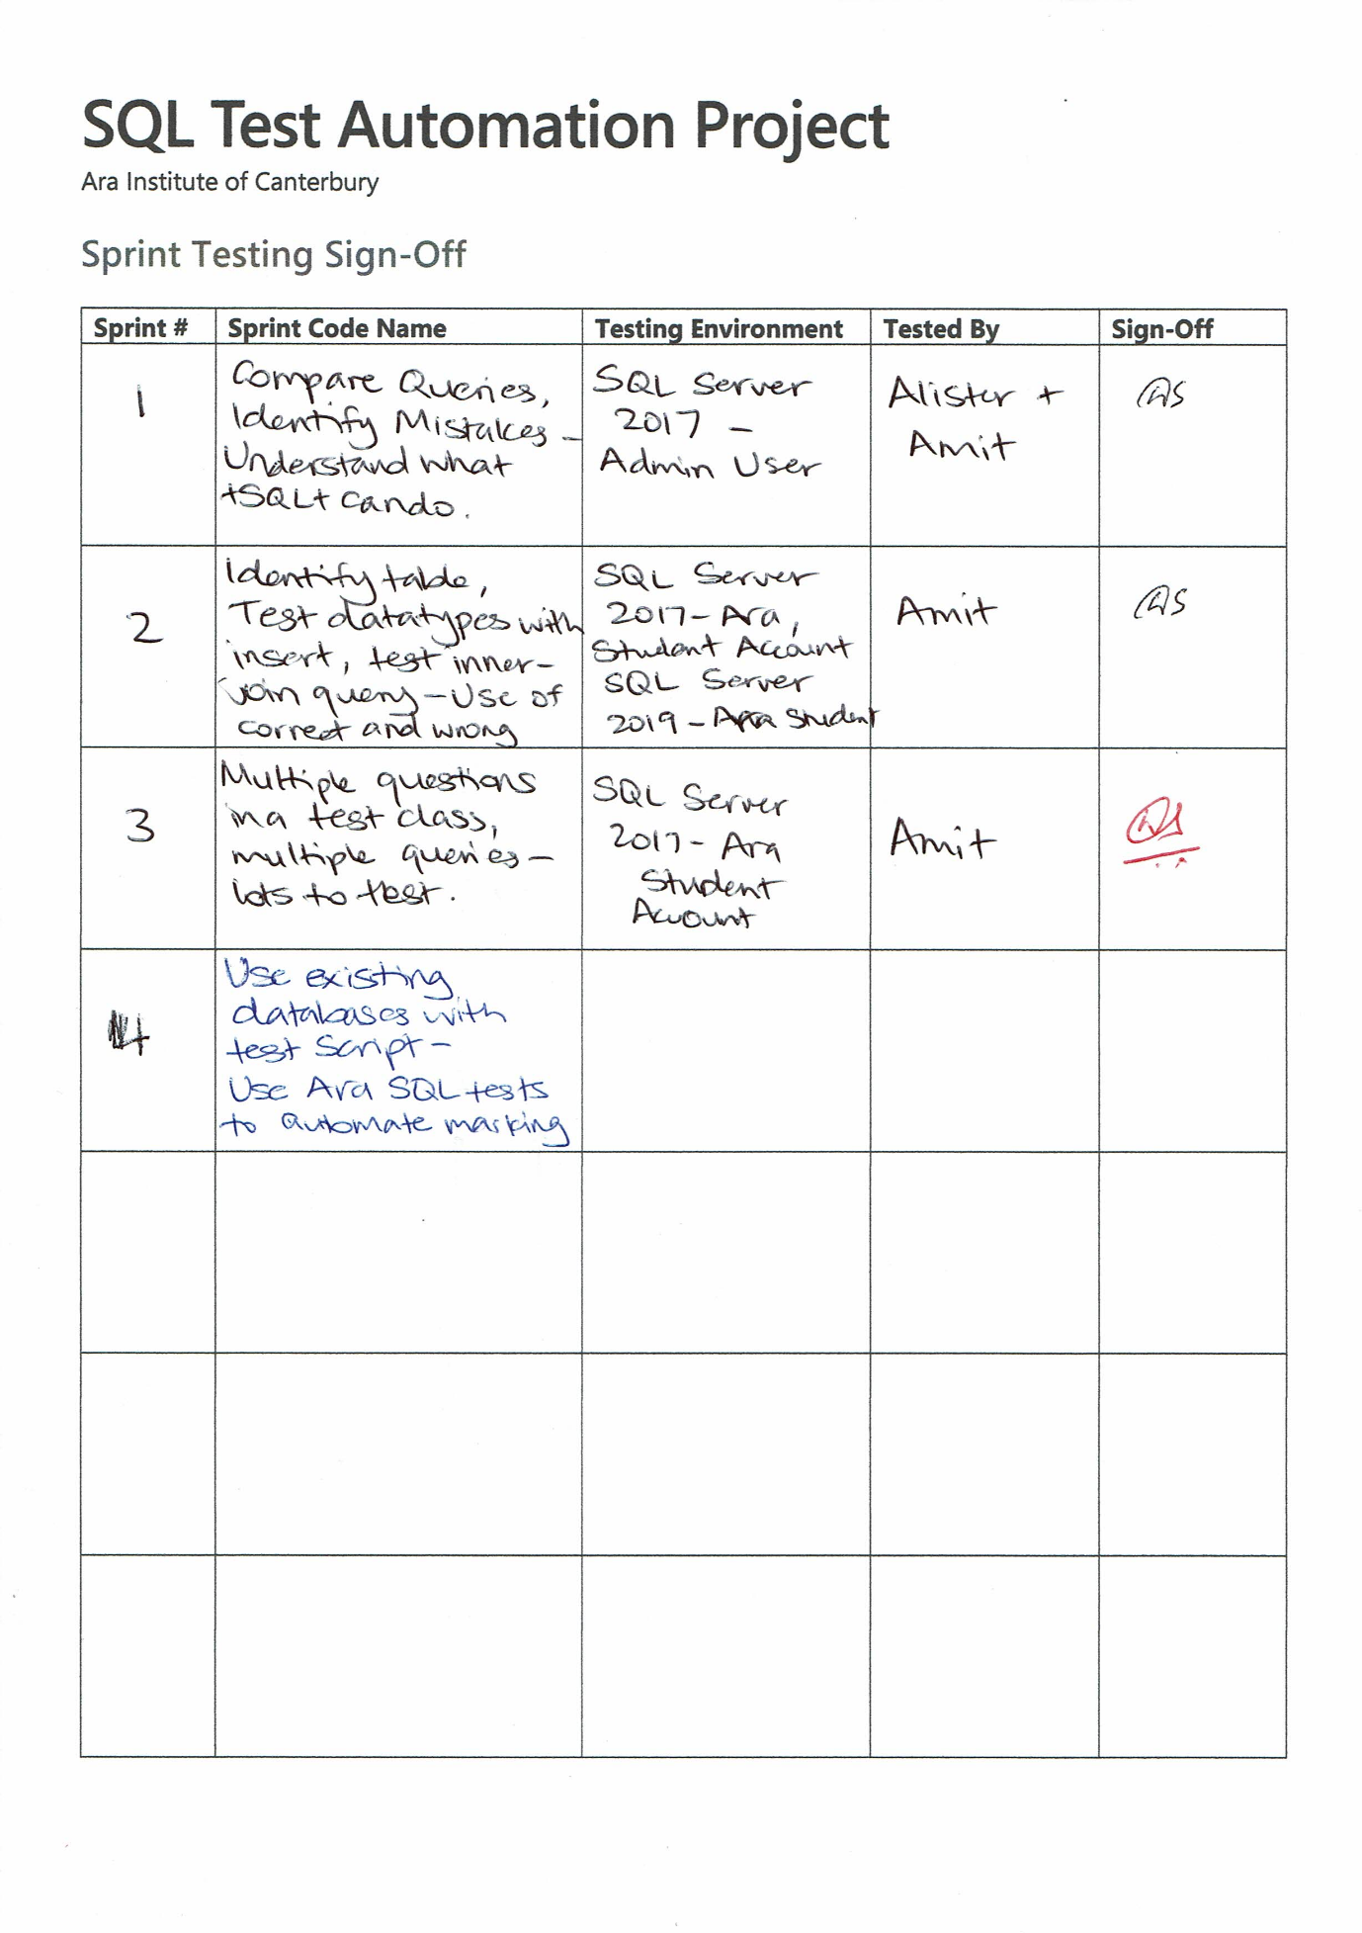

## Appendix D – Burndown Charts

### Appendix D1 – Industry Burndown

|  |  |  |  |  |  |
| --- | --- | --- | --- | --- | --- |
| **Industry Burndown** | | | | | |
| ***Aditya Raj - SQL Test Automation Project*** | | | | | |
|  |  | Hours per Week | | Remaining Hours | |
| # | Week | Planned | Actual | Planned | Actual |
| 7 | 5/04/2021 | 2 | 1.5 | 300 | 300 |
| 8 | 12/04/2021 | 30 | 26.5 | 270 | 273.5 |
| BK | 19/04/2021 | 30 | 17 | 240 | 256.5 |
| BK | 26/04/2021 | 30 | 21 | 210 | 235.5 |
| 9 | 3/05/2021 | 30 | 34 | 180 | 201.5 |
| 10 | 10/05/2021 | 30 | 34.5 | 150 | 167 |
| 11 | 17/05/2021 | 30 |  | 120 | 167 |
| 12 | 24/05/2021 | 30 |  | 90 | 167 |
| 13 | 31/05/2021 | 30 |  | 60 | 167 |
| 14 | 7/06/2021 | 30 |  | 30 | 167 |
| 15 | 14/06/2021 | 30 |  | 0 | 167 |
| **Total Industry Hours:** | | | **134.5** |  |  |

### Appendix D2 – Academic Burndown

|  |  |  |  |  |  |
| --- | --- | --- | --- | --- | --- |
| **Academic Burndown** | | | | | |
| ***Aditya Raj - SQL Test Automation Project*** | | | | | |
|  |  | Hours per Week | | Remaining Hours | |
| # | Week | Planned | Actual | Planned | Actual |
| 1 | 22/02/2021 | 9 | 4 | 150 | 150 |
| 2 | 1/03/2021 | 9 | 4 | 141 | 146 |
| 3 | 8/03/2021 | 9 | 4 | 132 | 142 |
| 4 | 15/03/2021 | 9 | 4 | 123 | 138 |
| 5 | 22/03/2021 | 9 | 8 | 114 | 130 |
| 6 | 29/03/2021 | 9 | 45 | 105 | 85 |
| 7 | 5/04/2021 | 9 | 13.5 | 96 | 71.5 |
| 8 | 12/04/2021 | 9 | 5 | 87 | 66.5 |
| BK | 19/04/2021 | 9 | 3 | 78 | 63.5 |
| BK | 26/04/2021 | 9 | 18 | 69 | 45.5 |
| 9 | 3/05/2021 | 9 | 22.5 | 60 | 23 |
| 10 | 10/05/2021 | 9 | 12 | 51 | 11 |
| 11 | 17/05/2021 | 9 |  | 42 | 11 |
| 12 | 24/05/2021 | 9 |  | 33 | 11 |
| 13 | 31/05/2021 | 9 |  | 24 | 11 |
| 14 | 7/06/2021 | 9 |  | 15 | 11 |
| 15 | 14/06/2021 | 9 |  | 6 | 11 |
| **Total Academic Hours:** | | | **143** |  |  |
| **Total Hours:** | | | **277.5** |  |  |
| **Weekly Meetings (Hours):** | | | **7** |  |  |

## Appendix E – Risk Management

### Appendix E1 – Risk Table

|  |  |  |  |  |  |  |  |  |
| --- | --- | --- | --- | --- | --- | --- | --- | --- |
| **Risk Assessment (Halfway Stage)** | | | | | | | | |
| ***Aditya Raj - SQL Test Automation Project*** | | | | | | | | |
| **#** | **Condition** | **Consequence** | **Probability** | **Impact** | **Exposure** | **Mitigation** | **Contingency** | **Triggers** |
| **1** | Not meeting submission deadlines | An increased workload due to not meeting project submission deadlines. | 90% | 9 | 8.1 | Break down tasks and get them done within a manageable timeframe before the submission deadline so that work is submitted on time. | Work harder to catching up to where I am supposed to be at with project work. | When the workload is getting harder to manage. |
| **2** | Sickness | Work deadline delays due to sickness (fever, weakness, cold) | 30% | 6 | 1.8 | Stay safe and healthy, keep warm, social distance, wash hands regularly, wear a mask in public. | Take medication on time and stay home. Get rest and eat healthily. Keep warm. Contact doctor to get tested. | When I get sick, feel weak and/or have symptoms of sickness. |
| **3** | Data loss/ corruption | Data lost due to accidental deletion or corruption or damage of hardware | 10% | 9 | 0.9 | Have many copies of files backed up on OneDrive and locally on an external hard drive or home desktop/laptop. Also, keep many versions to revert to if needed. | Use backup data from wherever available. | When some or all data is lost. |
| **4** | Major earthquake | Damage to home and workplace, unable to access work on the project. Possibly not internet or electricity. | 5% | 9 | 0.45 | Keep all documents on OneDrive and other places for easy access from anywhere. | Continue working from where possible. | Whenever it is safe to do so after the earthquake. |
| **5** | COVID-19 Alert Level change | Change to COVID-19 Alert Level 3 or 4, unable to work on the project at Ara, will have to work from home. | 5% | 5 | 0.25 | Be prepared to work from home, keep all documents on OneDrive and other places for easy access from anywhere. | Work from home, use the OneDrive pre-saved work to continue the project from home. | When government instructions are announced and/or have become active. |

## Appendix F – Quality Assurance

### Appendix F1 – Quality Assurance Table

|  |  |  |  |
| --- | --- | --- | --- |
| Deliverable | Development Phase | Success criteria/standards | Signees |
| The product marks student work from a directory (executed script with student code) and provides a correct or incorrect result. | Development & Testing | All code meets best programming practices and has been reviewed and tested by my industry supervisor to meet quality standards. The product produced expected results. | Amit Sarkar, Alister MacGregor |
| The product provides some words for feedback as to why the work is incorrect. | Development & Testing | All code meets best programming practices and has been reviewed and tested by my industry supervisor to meet quality standards. The product produced expected results. | Amit Sarkar, Alister MacGregor |
| The product allows students to self-mark, but without revealing to them the answers OR tutor uses the automated product to retrieve marks for the student work. | Development & Testing | All code meets best programming practices and has been reviewed and tested by my industry supervisor to meet quality standards. The product produced expected results. | Amit Sarkar, Alister MacGregor |
| The final deployable product without errors or bugs ready to use. | Development & Testing | All code meets best programming practices and has been reviewed and tested by my industry supervisor to meet quality standards. The product produced expected results. | Amit Sarkar, Alister MacGregor |
|  |  |  |  |